Lab 5 – Task 1 Report
Minimax: Manual Bottom-Up Trace of the Supplied Game Tree
Course: CAI601400 – Artificial Intelligence Student: Amina Mustafa – Roll No. 329

1. Problem Statement
A game-playing agent must choose a move while assuming the opponent also plays optimally. For the supplied two-player zero-sum game tree (Section 5.1), trace Minimax by hand from the leaves to the root, find the root value and the move MAX should choose, and verify the result with a program.

2. Assumptions
- The tree is the one in Section 5.1: scores = [3, 5, 2, 9, 0, 7]. The supplied code computes tree depth = ceil(log2(6)) = 3 and pads the list with 0 to 2³ = 8 leaves, giving [3, 5, 2, 9, 0, 7, 0, 0].
- Every internal node has two children; leaf i is at depth 3, and the children of node (d, i) are (d+1, 2i) and (d+1, 2i+1), as in the supplied code.
- The root (depth 0) is MAX; levels alternate MAX → MIN → MAX → leaves, so depth 1 is MIN and depth 2 is MAX.
- Leaf values are utilities for MAX. MAX wants the largest value and MIN the smallest.
- The two padded leaves (value 0) are part of the supplied tree and are treated as real leaves.

3. Game Tree
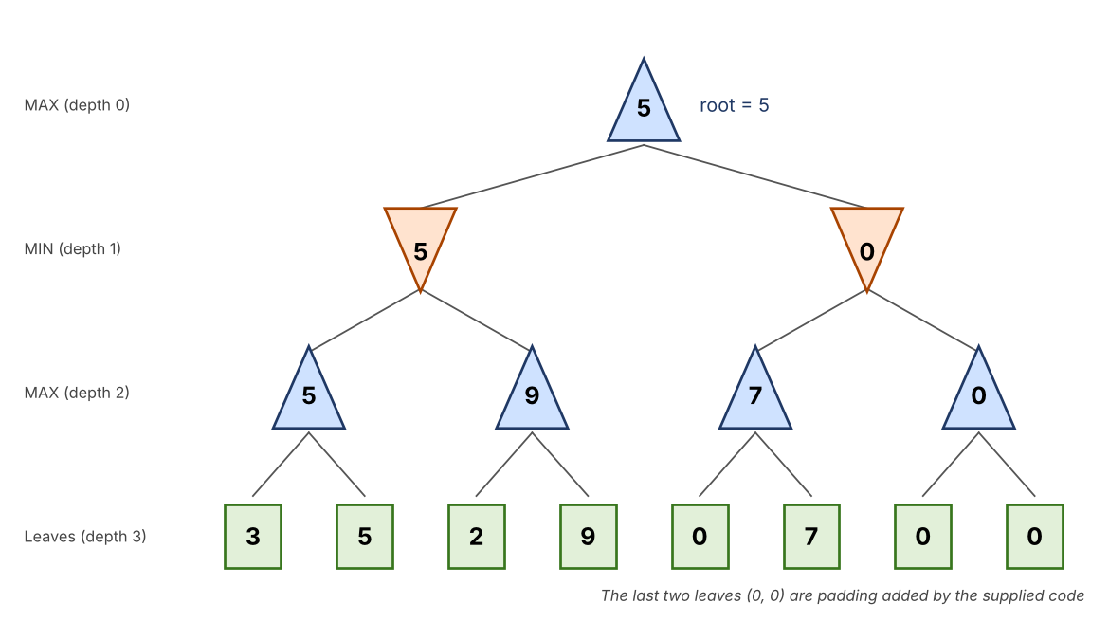
Figure 1: Supplied game tree with Minimax values (triangle up = MAX, triangle down = MIN)
Depth | Player | Nodes (index: children)
0 | MAX | #0: children #0, #1 (depth 1)
1 | MIN | #0: depth-2 nodes #0, #1; #1: depth-2 nodes #2, #3
2 | MAX | #0: leaves 3, 5; #1: leaves 2, 9; #2: leaves 0, 7; #3: leaves 0, 0
3 | Leaves | 3, 5, 2, 9, 0, 7, 0, 0

4. Minimax Rules
- MAX node: value = max of its children (MAX picks the best outcome for itself).
- MIN node: value = min of its children (MIN picks the outcome that is worst for MAX).
- Values are computed bottom-up: leaves first, then depth 2, depth 1 and finally the root.

5. Manual Bottom-Up Trace

Step 1: depth-2 MAX nodes
Node | Calculation | Value
MAX (d2, #0) | max(3, 5) | 5
MAX (d2, #1) | max(2, 9) | 9
MAX (d2, #2) | max(0, 7) | 7
MAX (d2, #3) | max(0, 0) | 0

Step 2: depth-1 MIN nodes
Node | Calculation | Value
MIN (d1, #0) | min(5, 9) | 5
MIN (d1, #1) | min(7, 0) | 0

Step 3: root MAX node
Node | Calculation | Value
MAX (d0, #0) | max(5, 0) | 5

Result: the Minimax value of the root is 5. MAX should move to the left child (value 5) rather than the right child (value 0).
Optimal line of play: MAX goes left; MIN then chooses the left depth-2 node (5) because 5 < 9; MAX then takes leaf 5 (5 > 3). The outcome is 5.
The order of computation printed by the program matches the manual trace: (d2,#0) = 5, (d2,#1) = 9, (d1,#0) = 5, (d2,#2) = 7, (d2,#3) = 0, (d1,#1) = 0, root = 5. The supplied minimax() function also returns 5.

7. Interpretation
- Why MAX assumes MIN picks the worst for MAX: the game is zero-sum, so what is best for MIN is worst for MAX; planning against the best opponent gives a guaranteed outcome.
- Why the right branch is poor: MIN can steer MAX into the padded subtree with value 0, so the right child is worth only 0, while the left child guarantees 5 even though it contains the high leaf 9, because MIN will avoid it.
- High leaves are not always reachable: leaf 9 exists, but at node (d1,#0) MIN chooses the smaller value 5, so MAX never gets 9 against an optimal opponent.
- Work done: plain Minimax visits all 8 leaves and 7 internal nodes (1 + 2 + 4); there is no pruning.

8. Edge Case / Failure Analysis
- Input: the same six scores but a different padding value for the two extra leaves (the supplied code pads with 0).
- Observed behaviour: pad = 0 gives root value 5; pad = 7 gives 7; pad = 9 gives 7 (see output).
- Likely cause: the padded leaves form the depth-2 node (d2,#3) = max(pad, pad) = pad, and the right MIN node is min(7, pad). With pad 0 the right branch is 0 and loses; with pad ≥ 7 the right branch is 7 and beats the left value 5.
- Proposed improvement: do not hide missing leaves with an arbitrary 0. Either use a tree whose leaf count is a power of two, or pad with a value that cannot be chosen (−∞ at MAX parents, +∞ at MIN parents), or build the tree explicitly with nodes that have one child.

11. Appendix: Python Code (Screenshots)
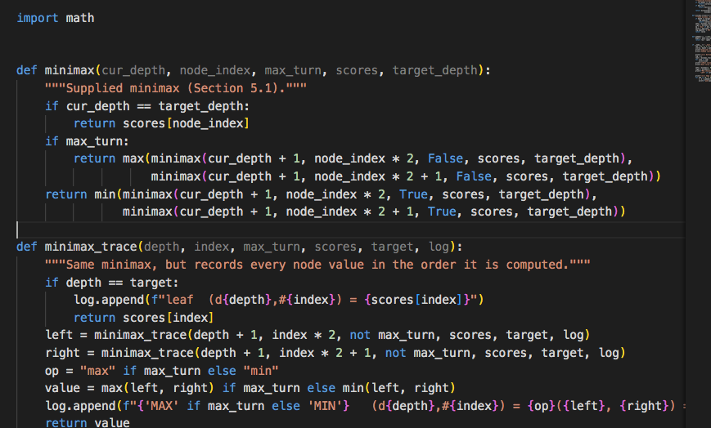
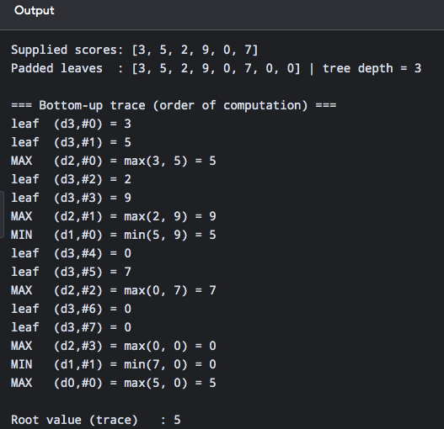

Lab 5 – Task 2 Report
Leaf-Evaluation Counter for Minimax and Alpha-Beta Pruning
Course: CAI601400 – Artificial Intelligence Student: Amina Mustafa – Roll No. 329

1. Problem Statement
Searching every leaf of a game tree is expensive. Add a leaf-evaluation counter to both Minimax and Alpha-Beta pruning, run them on the supplied trees, and show that they return the same root value while alpha-beta evaluates no more leaves than plain Minimax.

2. Assumptions and Counting Convention
- Both algorithms use the same complete binary tree, the same left-to-right child order and the same depth-first traversal.
- Leaf evaluated: a leaf whose score is read. Each leaf is recorded (by index) at the moment it is evaluated, so the counter is len(list) and the evaluation order is visible.
- Alpha-beta cuts when alpha ≥ beta, as in the supplied code (Section 5.2). A cut is logged only when it actually skips a child.
- Tree A (Section 5.1, padded): leaves [3, 5, 2, 9, 0, 7, 0, 0]. Tree B (Section 5.2): leaves [3, 5, 2, 9, 3, 5, 2, 9]. Both have depth 3 and 8 leaves.
- Levels alternate MAX (depth 0), MIN (depth 1), MAX (depth 2), leaves (depth 3).

3. Implementation Choices
- minimax() and alphabeta() take a list seen; each leaf appends its index to it. This gives both the count and the order, instead of an untraceable global number.
- alphabeta() also takes a list cuts that records every pruning decision with its alpha and beta, so another student can reproduce the result.
- compare() runs both algorithms on one tree and prints root values, leaf counts, skipped leaves and whether the root values agree.

5. Results

5.1 Comparison table
Tree | Root value | Minimax leaves | Alpha-beta leaves | Leaves saved
A: [3,5,2,9,0,7,0,0] | 5 | 8 | 8 | 0
B: [3,5,2,9,3,5,2,9] | 5 | 8 | 6 | 2 (25%)
Edge: all leaves 4 | 4 | 8 | 5 | 3
Edge: single leaf [7] | 7 | 1 | 1 | 0

In every case alpha-beta returns the same root value as Minimax and evaluates no more leaves.

5.2 Manual alpha-beta trace for Tree B
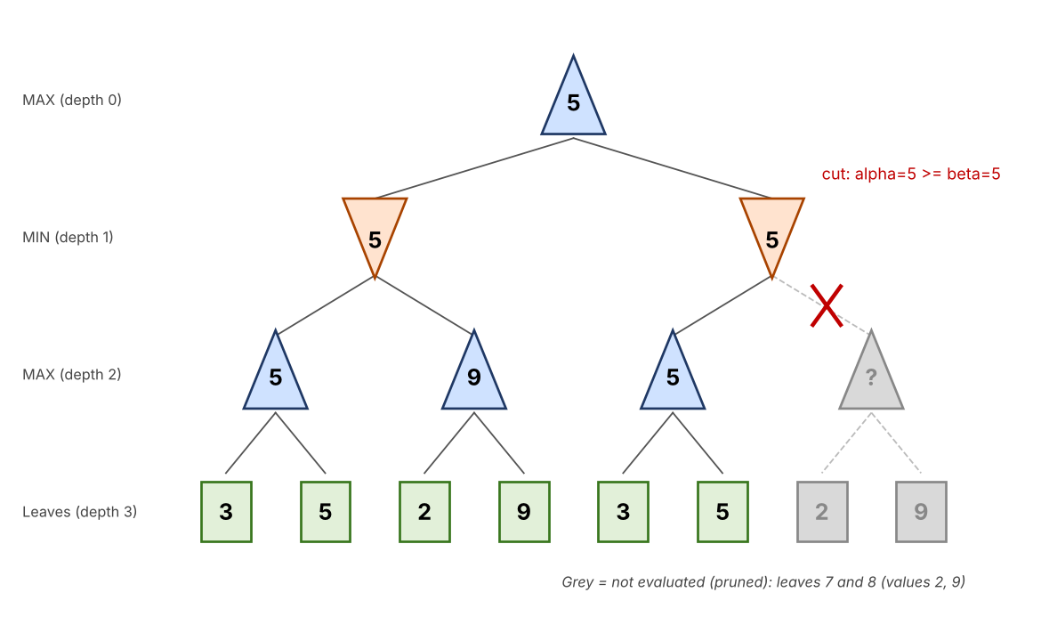
Figure 2: Tree B with alpha-beta pruning (grey = not evaluated)
Step | Node (α, β on entry) | Value | Action
1 | MAX (d2,#0) α=−∞, β=+∞ | 5 | leaf 3 → α=3; leaf 5 → value 5, α=5
2 | MIN (d1,#0) α=−∞, β=+∞ | 5 so far | child value 5 → β=5; −∞ ≥ 5 is false
3 | MAX (d2,#1) α=−∞, β=5 | 9 | leaf 2 → α=2; leaf 9 → value 9, α=9 ≥ 5, stop (no child left to skip)
4 | MIN (d1,#0) returns | 5 | min(5, 9) = 5
5 | MAX (d0,#0) α=5 | 5 so far | left value 5 → α=5
6 | MAX (d2,#2) α=5, β=+∞ | 5 | leaf 3 → value 3, α stays 5; leaf 5 → value 5
7 | MIN (d1,#1) α=5, β=+∞ | 5 | child value 5 → β=5; α=5 ≥ β=5 → CUT: (d2,#3) with leaves 2, 9 is skipped
8 | MAX (d0,#0) returns | 5 | max(5, 5) = 5

Leaves evaluated: 3, 5, 2, 9, 3, 5 (6 leaves). Skipped: the two leaves under (d2,#3).

5.3 Why Tree A shows no pruning
In Tree A the left MIN node gives α = 5 at the root. At the right MIN node β is first set to 7 (from the node with leaves 0 and 7), and 5 ≥ 7 is false, so the last MAX node (leaves 0, 0) must still be checked. No alpha-beta cut occurs, so all 8 leaves are evaluated.

6. Interpretation
- Same decision: the pruned leaves (2 and 9 in Tree B) cannot change the result. The right MIN node is already ≤ 5 after its first child, and MAX already has 5 from the left branch, so the remaining child cannot raise the root above 5.
- What alpha and beta mean: alpha is the best value MAX can already guarantee on the path to the root; beta is the best (lowest) value MIN can guarantee. When alpha ≥ beta the node cannot affect the decision.
- Savings depend on the tree: the same algorithm saved 2 leaves on Tree B and 0 on Tree A, so pruning depends on the leaf values and the order of the children (the subject of Task 3).
- Worst case: alpha-beta never evaluates more leaves than Minimax; in the worst case it evaluates all of them.

7. Edge-Case Tests
Test | Result | Observation
All leaves equal (4) | Root 4; 5 of 8 leaves evaluated | Equal values still cause cuts because alpha ≥ beta also holds with equality.
Single leaf [7] (depth 0) | Root 7; 1 leaf | No internal node, so nothing to prune.

8. Failure / Edge Case Analysis
- Input: Tree A, expecting alpha-beta to save leaves.
- Observed behaviour: alpha-beta evaluated all 8 leaves, the same as Minimax.
- Likely cause: with this child order the bounds never satisfy alpha ≥ beta (5 against 7), so no branch can be cut.
- Proposed improvement: order the children so the strongest moves are searched first (for example, evaluate the larger MAX child first), which makes cuts earlier. This is tested in Task 3.
- Limitation: these are very small trees; the measured savings (2 of 8 leaves) show the method works but do not predict the saving for large trees.

11. Appendix: Python Code (Screenshots)
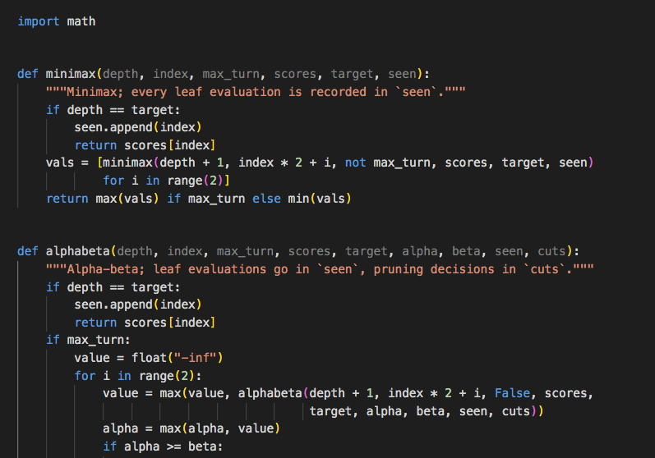
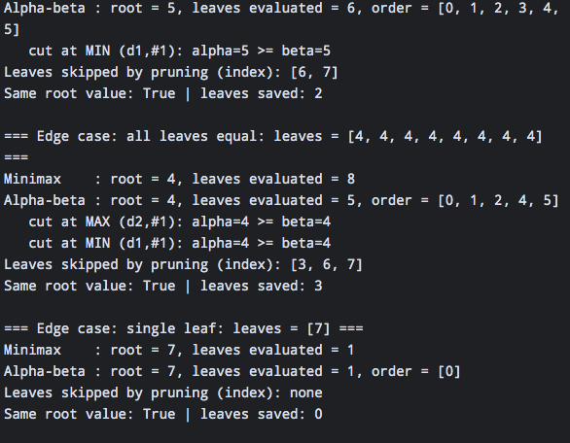

Lab 5 – Task 3 Report
Branch Reordering: Effect on Alpha-Beta Pruning, Same Minimax Value
Course: CAI601400 – Artificial Intelligence Student: Amina Mustafa – Roll No. 329

1. Problem Statement
Reorder the branches of the game tree and observe how alpha-beta pruning changes while the Minimax value stays the same. The goal is to show that move ordering affects the number of leaves evaluated but never the decision.

2. Assumptions
- Base tree is Tree B from Section 5.2: leaves [3, 5, 2, 9, 3, 5, 2, 9], depth 3, MAX at depths 0 and 2, MIN at depth 1.
- Reordering means swapping the left and right children of an internal node. Leaf values and the tree shape are unchanged, so the game is the same.
- A leaf is counted when its value is read (same convention as Task 2). Alpha-beta cuts when alpha ≥ beta.
- Best-first ordering: MAX nodes try the child with the larger Minimax value first, MIN nodes try the smaller first. Worst-first ordering: the opposite.

3. Implementation Choices
- The tree is stored as nested [left, right] lists, so branches can be reordered without changing the algorithms.
- swapped(tree, mask) swaps the children of every internal node whose bit is set in mask. With 7 internal nodes there are 2⁷ = 128 different orderings, and all of them are tested.
- order(tree, max_turn, best) builds the best-first or worst-first ordering from exact Minimax values.
- Every run records the leaves in the order alpha-beta evaluates them, so the result can be reproduced.

5. Results

5.1 Named orderings of Tree B
Ordering | Leaves (left to right) | Root value | Minimax leaves | Alpha-beta leaves
Original | 3, 5, 2, 9, 3, 5, 2, 9 | 5 | 8 | 6
Mirrored (all swapped) | 9, 2, 5, 3, 9, 2, 5, 3 | 5 | 8 | 8
Best-first | 5, 3, 9, 2, 5, 3, 9, 2 | 5 | 8 | 5
Worst-first | 2, 9, 3, 5, 2, 9, 3, 5 | 5 | 8 | 8

In all four orderings the root value is 5 for both Minimax and alpha-beta; only the number of leaves evaluated by alpha-beta changes (5 to 8).

5.2 Evaluation order of alpha-beta
Ordering | Leaves evaluated (in order) | Skipped
Original | 3, 5, 2, 9, 3, 5 | last two leaves (2, 9)
Mirrored | 9, 2, 5, 3, 9, 2, 5, 3 | none
Best-first | 5, 3, 9, 5, 3 | one leaf (2) and a pair (9, 2)
Worst-first | 2, 9, 3, 5, 2, 9, 3, 5 | none

5.3 Manual trace: best-first ordering (5 leaves)
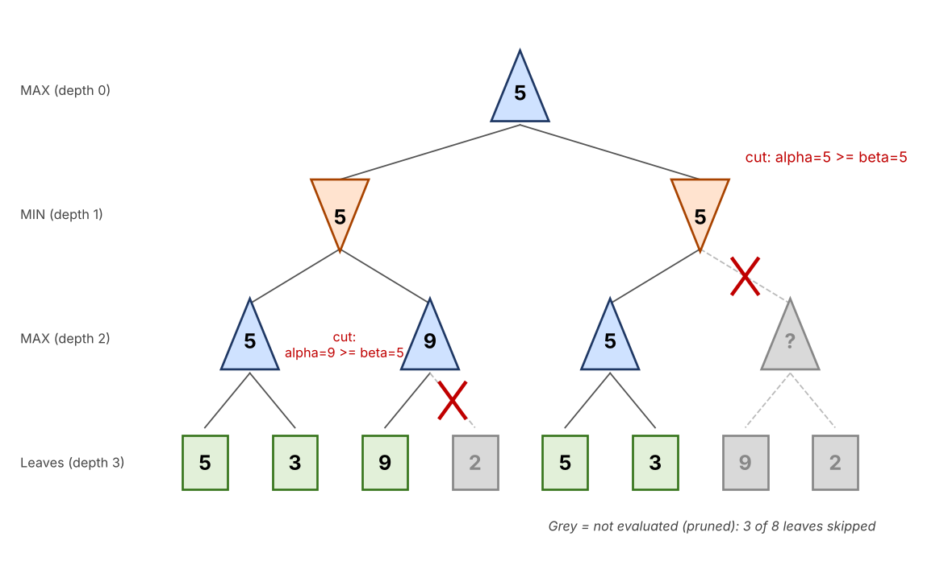
Figure 2: Best-first ordering with alpha-beta cuts (grey = not evaluated)
Step | Node (α, β on entry) | Value | Action
1 | MAX (d2,#0) α=−∞, β=+∞ | 5 | leaf 5 → α=5; leaf 3 → value stays 5
2 | MIN (d1,#0) α=−∞, β=+∞ | 5 so far | child value 5 → β=5
3 | MAX (d2,#1) α=−∞, β=5 | 9 | leaf 9 → value 9, α=9 ≥ β=5 → CUT: leaf 2 is skipped
4 | MIN (d1,#0) returns | 5 | min(5, 9) = 5; root α=5
5 | MAX (d2,#2) α=5, β=+∞ | 5 | leaf 5 → value 5, α=5; leaf 3 evaluated
6 | MIN (d1,#1) α=5, β=+∞ | 5 | child value 5 → β=5; α=5 ≥ β=5 → CUT: node (d2,#3) with leaves 9, 2 is skipped
7 | MAX (d0,#0) returns | 5 | max(5, 5) = 5

Leaves evaluated: 5, 3, 9, 5, 3 (5 of 8). Two cuts happened.

5.4 Why the worst-first and mirrored orderings prune nothing
In the worst-first ordering each MAX node meets its smaller leaf first and each MIN node meets its larger child first. For example, in the left MIN node the first MAX child returns 9, so β becomes 9; the second MAX child (leaves 3, 5) never gives a value ≥ 9, and in the right MIN node α = 5 stays below β = 9. Since α < β at every check, no cut is possible and all 8 leaves are evaluated. The mirrored ordering behaves in the same way.

5.5 All 128 orderings
Tree | Orderings | Min leaves | Max leaves | Mean leaves
Tree B [3,5,2,9,3,5,2,9] | 128 | 5 | 8 | 6.75
Tree A [3,5,2,9,0,7,0,0] | 128 | 5 | 8 | 7.00

For both trees, every one of the 128 orderings gave the root value 5 with both algorithms (the program printed only (5, 5) as the set of root values). Only the leaf count varied.

6. Interpretation
- The decision never changes: pruning only skips branches that cannot affect the root, so the Minimax value (5) is the same for every ordering.
- Ordering decides the savings: the same tree took 5, 6 or 8 leaves depending on the order of the children. Searching the strongest moves first lets alpha and beta cross earlier, so more branches are cut.
- Best case for this tree: 5 leaves. The known minimum for a binary tree of depth 3 is 2² + 2¹ − 1 = 5, which the best-first ordering reaches. The sweep also gave 5 as the minimum, so no ordering of this tree does better.
- Worst case: 8 leaves, the same as Minimax. Alpha-beta never evaluated more leaves than Minimax in any run.
- Average over all orderings: 6.75 leaves on Tree B, so on average 1.25 of 8 leaves (about 16%) were skipped.

7. Edge-Case Tests
Test | Result | Observation
Mirrored tree (all children swapped) | Root 5; 8 leaves | A simple mirror image can remove all pruning.
Tree A, all 128 orderings | Root 5; 5 to 8 leaves | Pruning is possible on Tree A only after reordering (it was 8 in the supplied order).

8. Failure / Edge Case Analysis
- Input: Tree B in worst-first (or mirrored) order.
- Observed behaviour: alpha-beta evaluated all 8 leaves, the same as plain Minimax; the pruning gave no saving.
- Likely cause: the weakest moves were searched first, so the bounds never satisfied α ≥ β.
- Proposed improvement: order the children with a cheap estimate (for example a heuristic evaluation, killer moves or the previous iteration’s best move) before searching them.
- Limitation: my best-first ordering uses exact Minimax values, which already require the full search. In a real game this is not available, so ordering can only be approximate and the saving will be smaller.

11. Appendix: Python Code (Screenshots)


